Class: 5
Period 62 Unit 10:Lesson 1 Activity 1-3
A. OBJECTIVES:
By the end of the lesson, Ss will be able to:
1. Knowledge:

- understand and correctly repeat the sentences in two communicative contexts in which characters ask and answer questions about a school trip.

- correctly say the words Ba Na Hills, Bai Dinh Pagoda, Hoan Kiem Lake, Suoi Tien Theme Park and use Did they go to ____? - Yes, they did / No, they didn’t. to ask and answer questions about school trips in the past.

- correctly use Did they go to ____? - Yes, they did. / No, they didn’t. to ask and answer questions in freer contexts.

- Vocabulary: hill, lake, park, pagoda.

- Structures: A: Did they go to Ba Na Hill?
B: Yes, they did / No, they didn’t.
- Skills: speaking and listening
2. Competences:
- Critical thinking and creativity: learn how to ask and answer questions about school trips in the past correctly and fluently.
- Communication and collaboration: work in pairs and groups to complete the learning tasks.
3. Attitude/ Qualities:
- Show their pride in famous places of Viet Nam.
- Show their love and interest in school trips.
B. TEACHING AIDS:
- Teacher: Teacher’s guide Pages 142, 143, 144, 145, audio Tracks 96, 97; website hoclieu.vn, posters, laptop, pictures, textbook, lesson plan, TV or projector.
- Students: Students’ book Page 68, notebooks, workbooks, school things.
C. PROCEDURES:
Teacher’s activities | Students’ activities
1.Warm- up and review: (3’)  Sing a song: A ram sam sam  *Aims: to create a friendly and active atmosphere in the class to beginning the lesson.  *Procedure:  - Show the song on the screen.  https://www.youtube.com/watch?v=SwjvlJCelN0  - Ask Ss to listen, sing and dance the song.  - Say “Open your book page 68” and look at “Unit 10, Lesson 1 (1,2,3)”.  2. Presentation (15’)  Activity 1. Vocabulary.  *Aims: Ss will be able to know the vocabulary in the new lesson.  *Procedure:  -T elicits the new words  + hill : đồi núi, đồi (explain)  + lake : hồ (picture)  + park : công viên (picture)  + pagoda : chùa (picture)  + theme park: công viên văn hóa (picture)  - T models (3 times).  - T writes the words on the board.  - Checking: Matching  Activity 2. Look, listen and repeat:  *Aims: Ss will be able to understand and correctly repeat the sentences in two communicative contexts in which characters ask and answer questions about a school trip.  *Procedure:  - Have Ss look at Pictures a and b and identify the characters and what they can see in the pictures.  + Who are they?  + Where are they?  + What are they talking about?  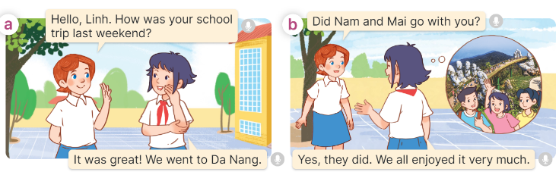  - Play the audio twice (sentence by sentence). Correct their pronunciation where necessary.  - Have Ss to practice the dialogue  - T invites a few pairs to the front of the class to practice.  - T checks pronunciation for ss.  Activity 3 Listen, point and say.  *Aims: Ss will be able to correctly say the words Ba Na Hills, Bai Dinh Pagoda, Hoan Kiem Lake, Suoi Tien Theme Park and use Did they go to ____? - Yes, they did / No, they didn’t. to ask and answer questions about school trips in the past.  *Procedure:  * Structures:  - T helps Ss know the structure from the dialogue.  - T introduces new structures for Ss.  - T explains, models and gives meaning.  - Have Ss repeat the structures  A: Did they go to Ba Na Hills?  B: Yes, they did / No, they didn’t.  3.Practice: (7’)  *Drill pictures  - Have Ss look at the pictures and identify the characters and places. 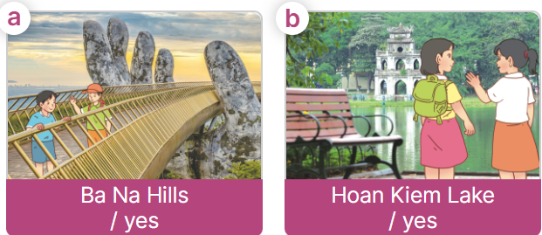  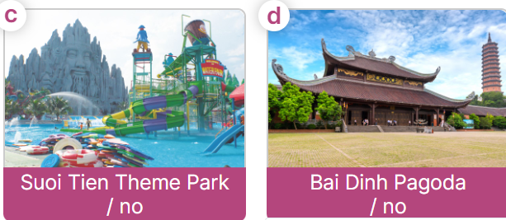  - Have Ss point at pictures, listen and run through all the pictures.  - Have Ss point at the bubbles, listen and run through model sentences.  - Have Ss to practise:  + T asks the first picture, Ss answer  + Ss asks the second picture, T answers  + Group A asks the third picture, group B  answers  + Group B asks the last picture, group A  - Ask Ss to work in pairs to practise asking and answering the Did they go to …….? Yes, they did / No, they didn’t.  - T controls and corrects.  - Invite a few pairs to point at the pictures and say the questions and answers in front of the class.  4. Production: (6’)  Activity 4. Let’s talk.  *Aims: Ss will be able to correctly use Did they go to ____? - Yes, they did. / No, they didn’t. to ask and answer questions in freer contexts.  *Procedure:  - Ask Ss to look at the pictures and elicit the context  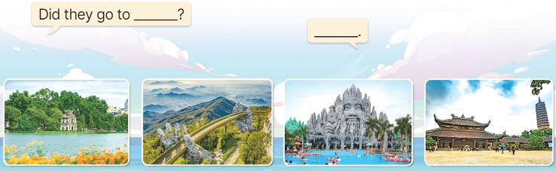  - Point at the ﬁrst building and elicit the question in the ﬁrst speech bubble Did they go to ____? and the answer in the second speech Yes, they did. / No, they didn’t. as an example.  - Give Ss time to work in pairs and take turns pointing at each picture to ask and answer using Did they go to ____? - Yes, they did. / No, they didn’t  - Invite a few pairs to come to the front of the classroom and act out the exchanges.  5. Fun corner and wrap- up (4’)  Game: Spinner game  - Prepare a spinner plate, a pen and some pictures about school trips in the past. Arrange the pictures in a circle around the spinner plate.  - Have ss work in four groups.  - Ask ss from each group to take turns to put a pen in the middle of the spinner plate, then spin the pen to find out the picture the pen points to. Then ask them to ask and answer the question with the picture.  - Ask ss to continue the game until all pupils in each group can play the game.  - Praise ss if they play the game well. | - Ss sing and dance the song together  - Ss listen and open their books  -Ss listen and answer  - - Ss listen and repeat  + Choral repetition (3 times).  + Individual repetition (3 ss)  - Ss take note  - Ss look and match  -Look at the pictures and say.  + In picture a:  Lucy: Hello, Linh. How was your school trip last weekend?  Linh: It was great! We went to Da Nang.  Miss Hoa: Well done.  + In picture b:  Lucy: Did Nam and Mai go with you?  Linh: Yes, they did. We all enjoyed it very much.  -Ss listen and repeat in chorus (twice)  -Ss work in pairs to practice  -Ss come to the front of the classroom to practice.  -Ss listen  - Ss look at the picture and answer.  -Ss listen  -Ss listen and repeat  -Ss repeat to the structures  - Ss look, listen and repeat  +Picture a: two boys at Ba Na Hills +Picture b: two girls at Hoan Kiem Lake  + Picture c: Some children at Suoi Tien Theme Park  + Picture d: Bai Dinh Pagoda  -Ss point at pictures, listen and repeat  -Ss point at the bubbles, listen and repeat  -Ss practice in chorus  -Ss practice in chorus  -Ss work in pairs to practise asking and answering the question  - Pairs of Ss point at the pictures and say in front of the class  -Ss look at the picture and say  + Hoan Kiem Lake, Suoi Tien Theme Park, Bai Dinh Pagoda, Ba Na Hills  - Ss look at the first building and elicit the missing words and say the completed sentences.  - Ss role-play to practise asking and answering questions  - Ss practise asking and answering questions in front of the class.  -Ss listen to the teacher  -Ss play the game  Ex:  A: Did you go to Ba Na Hill last weekend?  B: Yes, I did. / No, I didn’t.  -Ss continute to play the game  -Ss praise the winner

